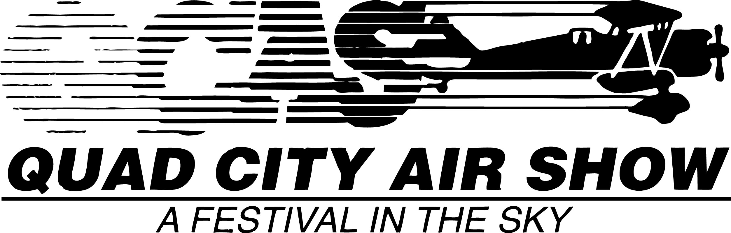
34th - Quad City Air Show
2 0 2 5
P.O. Box 18 * Eldridge, IA 52748
563-349-0400 * 563-349-0044
Dear Potential Vendor or Exhibitor

Thank you for your interest in the 34th - 2025 Quad City Air Show is scheduled for August 23-24, 2025. This TRADITION of EXCELLENCE continues as we celebrate the RETURN of the INCREDIBLE United States AIR FORCE THUNDERBIRDS! Besides being recognized as one of the TOP-THREE air shows in the country and was selected the NUMBER ONE LARGE Air Show of the Year in 2011 by the United States Navy, we are also ONE of the longest running air shows in the WORLD - as 2025 will mark our 34th - Air Show.

Each and every show the Quad City Air Show is the most anticipated event in the area, region, state. We know that Nothing Comes Close to this event and we want you to experience it first-hand. Whether it be the unbelievable United States Military Demonstration Teams or aircraft and exhibits, best performers in the industry, as well as Iowa Pork Sandwiches, funnel cakes, Ice Cream, Car and truck displays, antiques, crafts, face painting, sampling products and just about anything and everything at the Quad City Air Show is THE place to showcase your product or service.

As an official partner with the Quad City Air Show, you will be mentioned at the air show, listed on the official web-site and listed in the official air show program.

Besides being a vendor/exhibitor, consider becoming a SPONSOR of this incredible family event, where you could receive VIP passes, party invites, aircraft rides, VIP parking, media mentions and much more.

I look forward to working with you to develop a plan that is successful and help fulfill your goals for the season. If you have any questions, require more information, please feel free to contact the Air Show office at INFO@quadcityairshow.com or email me at Boss@quadcityairshow.COM or check our web at www.quadcityairshow.com.
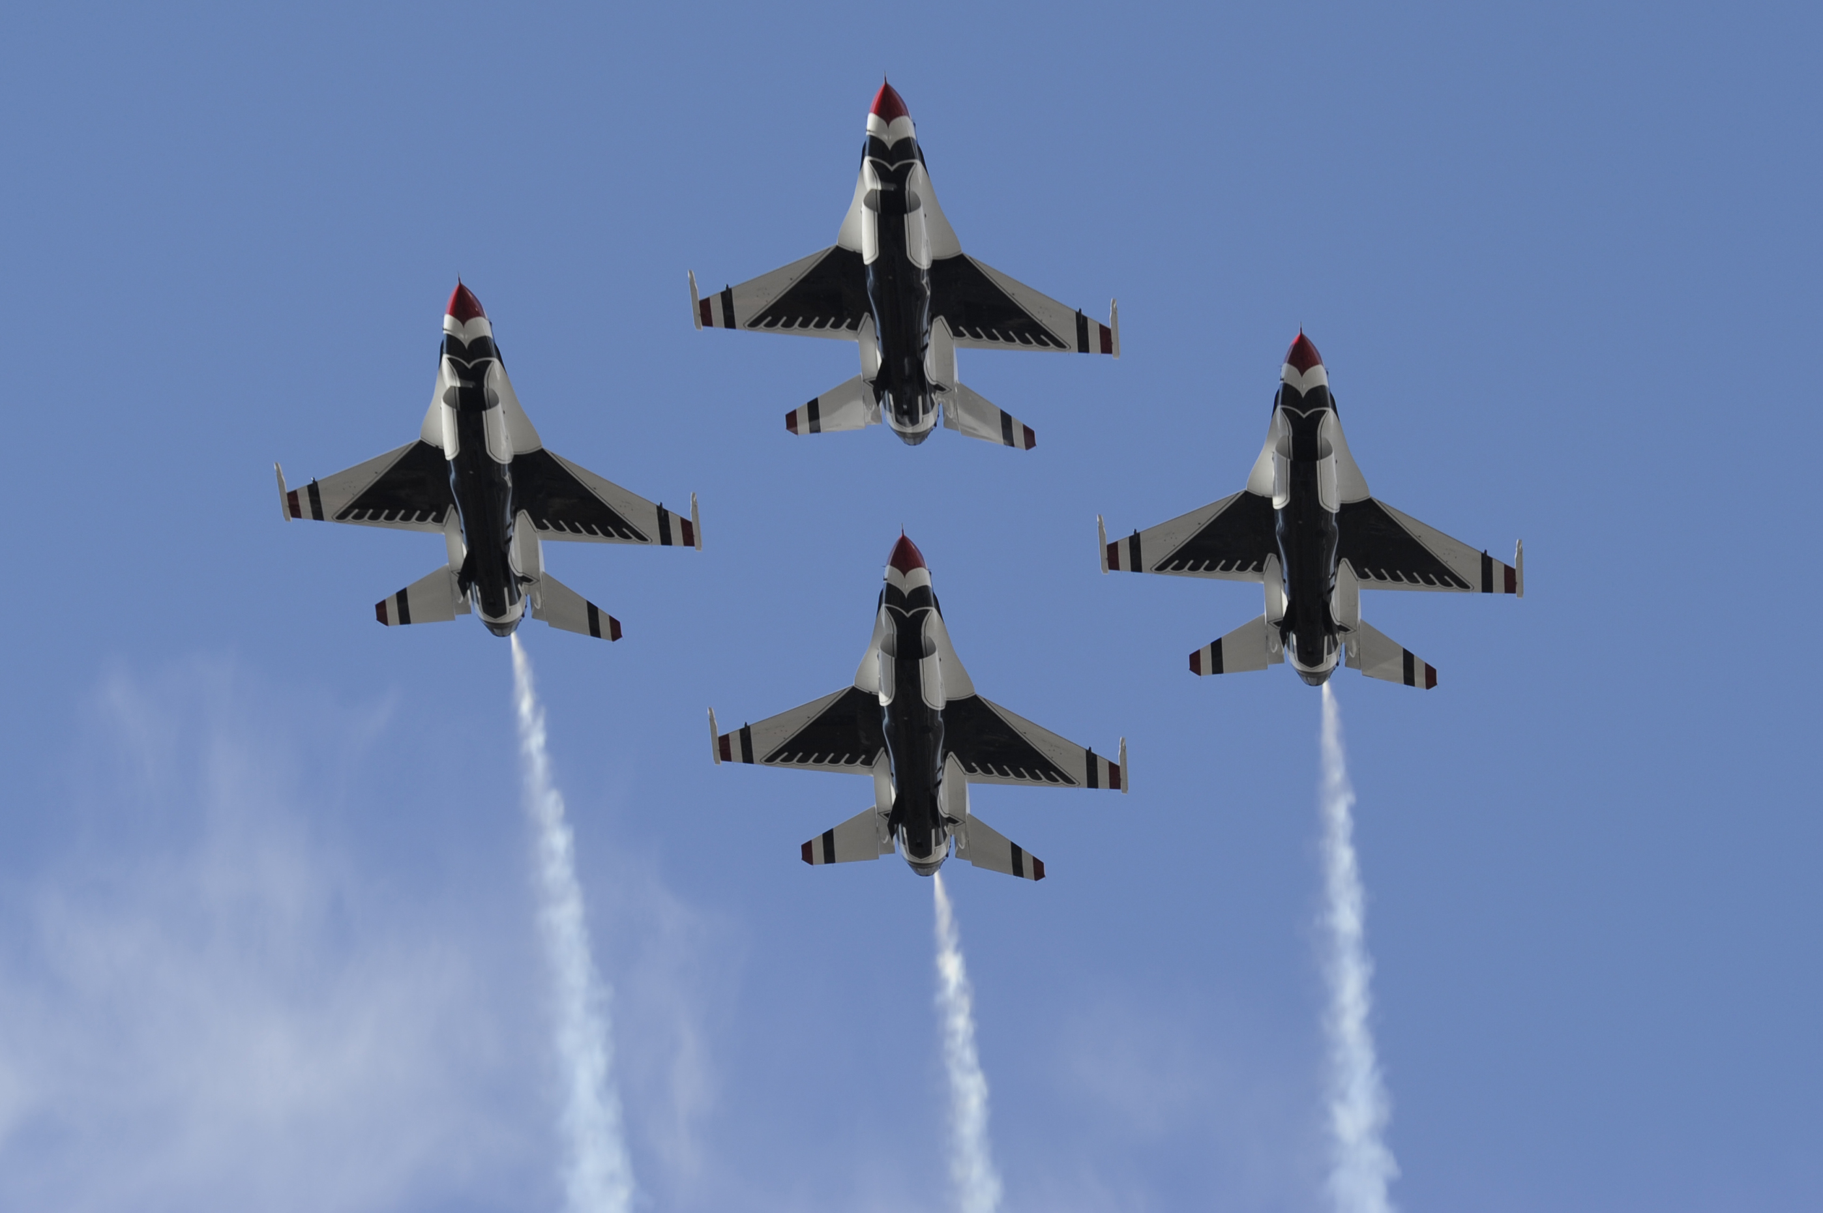

Best Wishes & Be Safe,
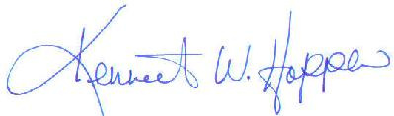
Kenneth W. Hopper
Chairman-Founder-Air Boss
THE 34th - QUAD CITY AIR SHOW IN 2025
(25vendorapplication)
2025 - QCAS - Outside Exhibitor/Display Application

Outside Exhibitor/Display Contract - Option

Company Name: ____________________________________ Contact: _______________________
Address: ___________________________________________ City: __________________________
State: ____ Zip-code: ________ Phone: _________________ Email: ________________________
Sales Tax (IA) Number: ____________________ (or) use our Permanent Number _______________

Number of Locations requested: _____ Size: ___10*10 ___10*20___20*20___30*30___40*40
___50*50 - if Larger then 50*50, what size_______ we will determine price and get back to you.
Price: 10*10 - $1,500.00 10*20 - $ 2,000.00 20*20 - $2,500.00 30*30 - $ 3,000.00
40*40 - $3,500.00 50*50 - $ 5,000.00 Larger size the price is: ____________ as QCAS determines.

Number of Booths from above: ______ Total booth fee as determined above: $________

Total Transferred from the Vendor Additional Items order form $________
Total AMOUNT DUE THE QUAD CITY AIR SHOW - 2025 $________
(all checks and/or credit/debit card deemed insufficient and returned will be charged a fee of $75.00 plus any/all collection costs)

RULES STATEMENT:

Vendor(licensee) to use the space for the purpose of displaying, distributing, signing up customers – NO SELLING of Food and beverage items products or any air show type novelty items at the 2025 QCAS, for which the licensee agrees to pay the said sum listed above to the Quad City Air Show (licensor). It then is agreed that the licensee will follow all rules and regulations as established by the QCAS. Will complete all required paperwork for this application. Which includes: Application, Vendor & Exhibitor additional items form, signed waiver release and provide a certificate of insurance as well as submit full payment to the Quad City Air Show for consideration. All vendors, exhibitors understand that all items required for your display are your responsibility, if you need additional items, please complete the VENDOR/EXHIBITOR additional items form. Please read and review the Exhibitor/Vendor Information. You will receive two (2) daily vendor passes and one (1) vendor parking per display, if others are required please indicate on Additional Form. If you ordered any additional items above they will be included and given to you on-site at check-in.

It is clearly stated here and you agree that NO FOOD OR BEVERAGE is to be sold in any outside vendor, display or exhibitor area. If you want to SELL these types of products, you MUST complete the Food & Beverage application.
As if you are caught selling non-approved items, you will be asked to leave and receive no refund.

Please sign and date here that you fully understand your responsibility:

______________________________ ____________________________________ _____________
Signature of Vendor Printed Name of Vendor Date Signed
34th - Quad City Air Show
2 0 2 5
P.O. Box 18 * Eldridge, IA 52748
563-349-0400 * 563-349-0044
Waiver of Liability, Release and Hold Harmless Agreement

In consideration of being permitted to participate in any and all activities at the 2025 Quad City Air Show, I for myself, organization and company, release and forever discharge (and covenant not to sue) the Quad City Air Show, its agents, volunteers, directors, managers, board members of and from any and every claim, demand, action or right of action, of whatsoever kind of nature, arising from or by reason of any bodily injury or property damage or for any reason which may occur as a result of my (our) participation in the 2025 Quad City Air Show and all events and activities conducted by or sanctioned by Aerial Promotions, Inc., dba the Quad City Air Show.

I hereby expressly agree that this Waiver of Liability, Release and Hold Harmless Agreement is intended to be as broad and inclusive as permitted by the laws of the State of Iowa and that if any portion hereof is held invalid, it is agreed that the balance shall, notwithstanding, continue in full legal force and effect.

Participant, vendor, exhibitor, contractor agrees to indemnify and hold the Quad City Air Show and its officers, directors, agents, employees and volunteers harmless and to defend the Quad City Air Show at contractors sole expense, for all losses, liability and expenses including the Quad City Air Show litigation costs and attorneys fees and all claims and demands of every kind and nature, based upon damage and injury to persons or property, including death, arising in any manner from contractors activities or from any condition of the events sites created by contractors activities. In addition, contractor shall indemnify and hold harmless the Quad City Air Show and shall defend the Quad City Air Show from any and all claims of breach of terms of the Quad City Air Show permit for use of event sites that may arise as a result of contractors activities and/or action.

Contractor must provide a certificate of insurance naming the "Quad City Air Show" as an additional insured with limits at a minimum of One Million dollars, ($1,000,000.00). Make sure all policies are valid, current and reflect the time frame of the 2025 Quad City Air Show. This certificate of insurance must be sent to the Quad City Air Show before set-up will be permitted.

If you are selling Food Items, please submit a photo of your trailer, tent or equipment, along with a listing of items offered and prices of said items. It is understood that the Quad City Air Show reserves the sole right to prohibit the sale of such items that are deemed offensive, unsafe or unsuitable for sale at the Quad City Air Show.

By signing this sheet you agree to adhere by all rules and regulations, will provide all required paperwork prior to set-up, along with full payment upfront. Please retain a copy of all paperwork for your personal records. Finally, the Quad City Air Show makes no representation of any level of sales, as each event is unique and no guarantees of any level are discussed or implied.

(Important: - This agreement falls under the FORCE MAJEURE CLAUSE – if cancelled for any reason by Local, City, County, State or Federal authorities or for any reason beyond the control of the Quad City Air Show, this contract is void and any fees paid are forfeited).

_____________________________ _________________________________ _____________
Signature of Vendor, Contractor Printed Name of Vendor, Contractor Date Signed


VENDOR/EXHIBITOR/DISPLAY
Additional Items Order Form
34th - 2025 - Quad City Air Show

Vendor/Exhibitor/Display Name: _______
Address: _______
City: __________________________ State: __________ Zip:_________ Phone: ____________________
Contact Name: _____________________________ Email: _______________________________________
TYPE | COST EACH | QUANTITY | SUB-TOTAL
 |  |  | $
Admission Pass (one day) | $15.00 |  | $
Admission Pass (weekend) | $20.00 |  | $
Vendor Parking (weekend) | $20.00 |  | $
NO POWER Available
Camping On-Site - Limited | $500.00 |  | $
(No Services Provided)
Golf Cart Box Reg | $350.00 |  | $
(Subject to availability)
20-24 pound bag of Ice | $8.00 |  | $
You can order more ice on-site
Tent – 10 x 10’ | $350.00 |  | $
Tent – 20 x 20’ | $650.00 |  | $
Tent Prices are prior to April 1 After that add 50% surcharge for late order. |  |  | $
Table – 8’ rectangle | $25.00 |  | $
Chair – Folding | $10.00 |  | $
You are responsible for all tables and chairs and will be charged $200.00 per table and $25.00 per chair if not returned to proper location.
Total DUE QUAD CITY AIR SHOW: |  |  | $
PAID CHECK NUMBER:
MC/VISA/Discover/AMEX NUMBER:
EXPIRATION DATE:
SIGNATURE:

NOTE: Please carry this total amount to the Application Page and total all amounts, send that amount with all proper completed forms to the Quad City Air Show office for consideration.
SPECIAL NOTE: - If you rent a golf cart, tent, table or any item for the Quad City Air Show, you will be responsible for any and all damage to the item(s). By signing this, you agree to pay for all damage.

EXHIBITOR / VENDOR INFORMATION
Checklist –General Event Information
34th - Quad City Air Show - 2025
Event Name: | Quad City Air Show – Sounds of Freedom – Military-Music-Fireworks
Event Date: | August 23-24, 2025 – Saturday – Day & – Sunday – Day Show
Venue Address | Davenport Municipal Airport - (Airport code is KDVN)  9010 Harrison Street - Davenport, Iowa 52804 (Hwy 61 N to Exit 124)
Show Telephone | (563) 349-0044 – This is our main line for questions until show time.
Event Contact: | Ken - Chairman - 563-349-0044 - Margie – Vice President - 563-349-0400
Event Web-Site: | www.quadcityairshow.com Email: INFO@quadcityairshow.com
Administration Contact: | Margie Hopper – Vice President - 563-349-0400
Site Contact: | Dave Schumacher – Director - Vendor Operations – 563-321-9093  Prior to actual air show set-up Please contact Ken or Margie if "?"
Admission Gate: | Either day - Adult - $35.00 prior to 12/31/24 then $40.00 until 6/1/25 then $45.00 until 8/22/25 then $60.00 at the gate. (under 10 free)  (Vendors get a special, discounted price – see additional items sheet)
Estimated Attendance: | 40,000-50,000 spectators DAILY is what we expect at our 2025 show
Hours of Operation | Air Show is Saturday & Sunday – August 23-24, 2025
Dates of Operation: | Friday, August 22- Press - SHOW Saturday & Sunday, August 23-24, 2025
Hours of Operation: | Friday – 0800-1600 (Press Day)  Saturday – 0800-1700 (8am-5pm) – Day Air Show  Sunday – 0800-1700 (8am-5pm) – Day Air Show
Event Set-up Dates: | Thursday & Friday - August 21-22, 2025 – 7am-4pm
Earliest Available: | Wednesday, August 20, 2025 – call for possible times
Break-down: | Monday, August 25, 2025 – any time after 7am until 6pm
Earliest Available: | Sunday, August 24, 2025 – after show from 5pm until 9pm
Space vacated by: | Tuesday, August 26, 2025 - 0900 (9am) or pay an additional late fee
Directions to site: | (Right off I-80) – Interstate 80 to Highway 61 North. Highway 61 North off I-80 is EXIT 295. Then head North on Highway 61 to EXIT 124 (first exit on highway 61). Follow signs to airport.
Truck Entrance: | Gate VE – Vendor entrance during show Set-up & weekend of air show.
Location: | As determined by the Air Show Management and type of booth space
Truck / Trailer access | Yes
Parking on: | Grass or possible concrete if available.
Size of area | Depends on type of booth or exhibit
Marquee Space: | Yes – you can place banners around show grounds. You must supply, install and remove, we are not responsible for them. (Subject to inspection and no conflict with our sponsors).
Tractor Parking: | Yes, in vendor parking restricted areas determined by QCAS
Page 2 - Information - 2025 | Quad City Air Show - August 23-24, 2025 – A Salute to the Military
Electric: | Provide your own. (If enough time, we may be able to locate a power unit, but NLT May 1, 2025 – Will be charged extra for such unit).
Fuel: | For your vehicles is located within 1/4 mile from airport. BP Amoco Gas / Diesel Station and we may be able to sell small amounts on site.
Water Hookup: | Yes if close to a building that has water connections and if management agrees, plus need own hoses. Very Limited. (You can fill up there if must)
Permits: | For food/beverage products, then call the Scott County Health Department at (563) 326-8618 for a Event Food Permit – Must Have!
Set-up equipment: | If you require set-up equipment like fork trucks, lifts, tents, etc, please contact the QCAS office and we might be able to arrange for those items.
Security: | John P. Norris – QCAS Director of Security & Safety  (563) 349-2398 – We can arrange for 24 hour security if this is required.
Temporary Services: | Contact us for information on possible support, we then can help locate groups or temporary personnel to support your needs. (NO guarantee)!  Margie C. Hopper (563) 349-0400 or Evan Hopper (563) 650-2452
Additional Insured: | Aerial Promotions, Inc. – Iowa Non-Profit – 501(c)(3)  Quad City Air Show
Local Hotels: | Best Western – Steeplegate  (563) 386-6900  Davenport - (off I-80 at exit 295)
SPONSOR HOTEL  Isle Casino & Hotel  800-724-5825  1777 Isle Parkway - Bettendorf, IA 52722 | Days Inn  (563) 391-8222  Davenport - (off I-80 at exit 292)
SPONSOR HOTEL  Bally’s Casino & Hotel  800-477-7747  777 Jumer Drive  Rock Island, IL 61201 | Home to Suites  (563) 345*1130  975 Utica Ridge Road  Bettendorf - (off I-74 at Exit 2)
Quality Inn
(563) 285-4600
Eldridge (exit 127 off highway 61)
Comfort Inn & Suites
(563) 324-8300
Davenport (off I-80 at Exit 292)

END OF 2025 VENDOR/DISPLAY/FOOD/BEVERAGE/EXHIBITOR APPLICATION - THANK YOU

