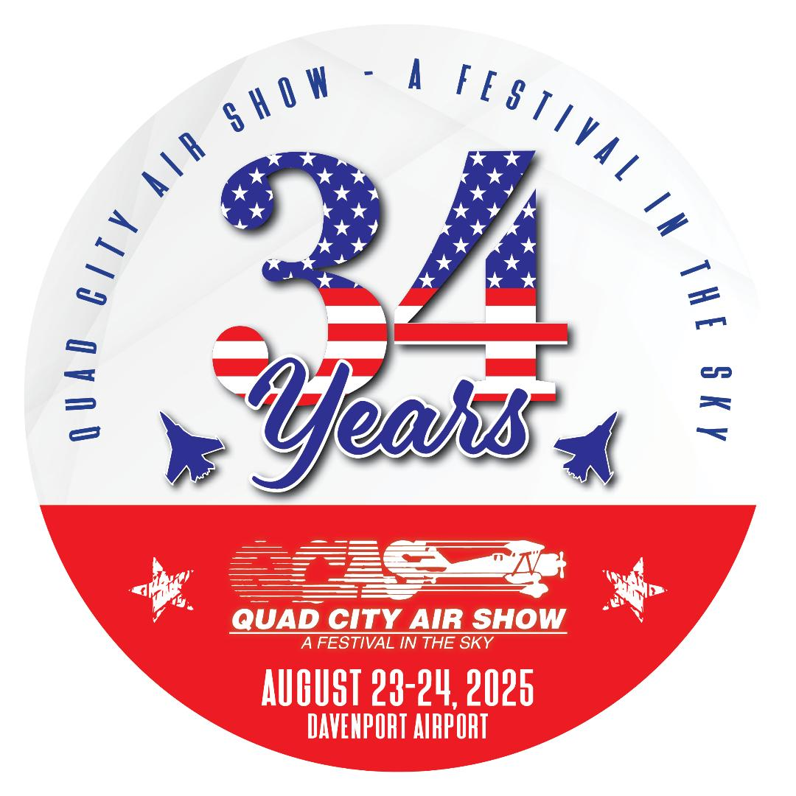

MEDIA CREDENTIAL APPLICATION – 2025
The Quad City Air Show is compiling a list of local and regional media personnel who wish to receive Media Credentials for the Air Show to be held on Friday Special Press/Practice and the Air Show on Saturday & Sunday, August 22-23-24, 2025 at the Davenport Airport.
This year, our 34th - Air Show is shaping up to be the best one to date, please see our web site for a list of performers. Come and see the best civilians as well as displays from the military and the best novelties and food found at any outdoor family event ... Featuring the Incredible - United States AIR FORCE THUNDERBIRDS!!
If you are interested in obtaining Media Credentials, please complete the form below and EMAIL this application back to us NO LATER THAN MAY 31, 2025. This media badge allows you access to all general areas, please adhere to all restricted signage for safety reasons.
MEDIA NAME: ___________________________________________________________
ADDRESS: ________________________________________________________________
CITY: __________________ STATE: __________ZIP:____________________________
PHONE: ____________________________ CONTACT: ___________________________
EMAIL: ___________________________________________________________________
I NEED ______ / # of Media Credentials.
Names of people: ____________________________
____________________________
____________________________
Prepared by: ____________________________
Date: ____________________________

The Quad City Air Show reserves the right to limit the number of credentials issued… Please return via email: QCASBOSS@AOL.COM or mail to QCAS P.O. Box18 – Eldridge, IA 52748-0018 or call 563-349-0044 – website is - www.quadcityairshow.com

