CORPORATE CHALET - 2019


FUN-REWARDING-ENTERTAINING-FRONT ROW
JUNE 29-30, 2019 - QCAS # 31

A Quad City Air Show Corporate Chalet is the perfect place to create your own private area to entertain, reward, thank and showcase your company to your very important clients, customers, employees, friends and family all at a Private Chalet on the Front Line at the Premier Event in the Quad Cities. This Private chalet is reasonable, first-class and is ready to give you a front seat for non-stop aerial action from the best entertainers in the world.

2019 – CORPORATE CHALET OPTIONS – 2019
- Mini Chalet One Day - $ 4,000.00 (Saturday or Sunday) or Weekend - $5,000.00
- Small Chalet for One Day – $ 8,000.00 (Saturday or Sunday) or Weekend - $10,000.00
- Regular Chalet for One Day – $12,000.00 (Saturday or Sunday) or Weekend - $14,000.00
- Large Chalet for One Day – $ 15,000.00 (Saturday or Sunday) or Weekend - $20,000.00
- Super Chalet for One Day - $ 25,000.00 (Saturday or Sunday) or Weekend - $ 40,000.00

Please note: The Quad City Air Show will handle all of your professional catering needs. The food portion is included in the price above BUT ONLY ON CASH CHALETS NOT FOR TRADE CHALETS. For beverage & ice please complete the BEVERAGE & ICE SHEET and return prior to June 1, 2019. If you do not want food included with your chalet the price will be 10% less, (again CASH chalets only - not for TRADE chalets), then you are responsible for your own food service.

CHALET IS FURNISHED AS FOLLOWS
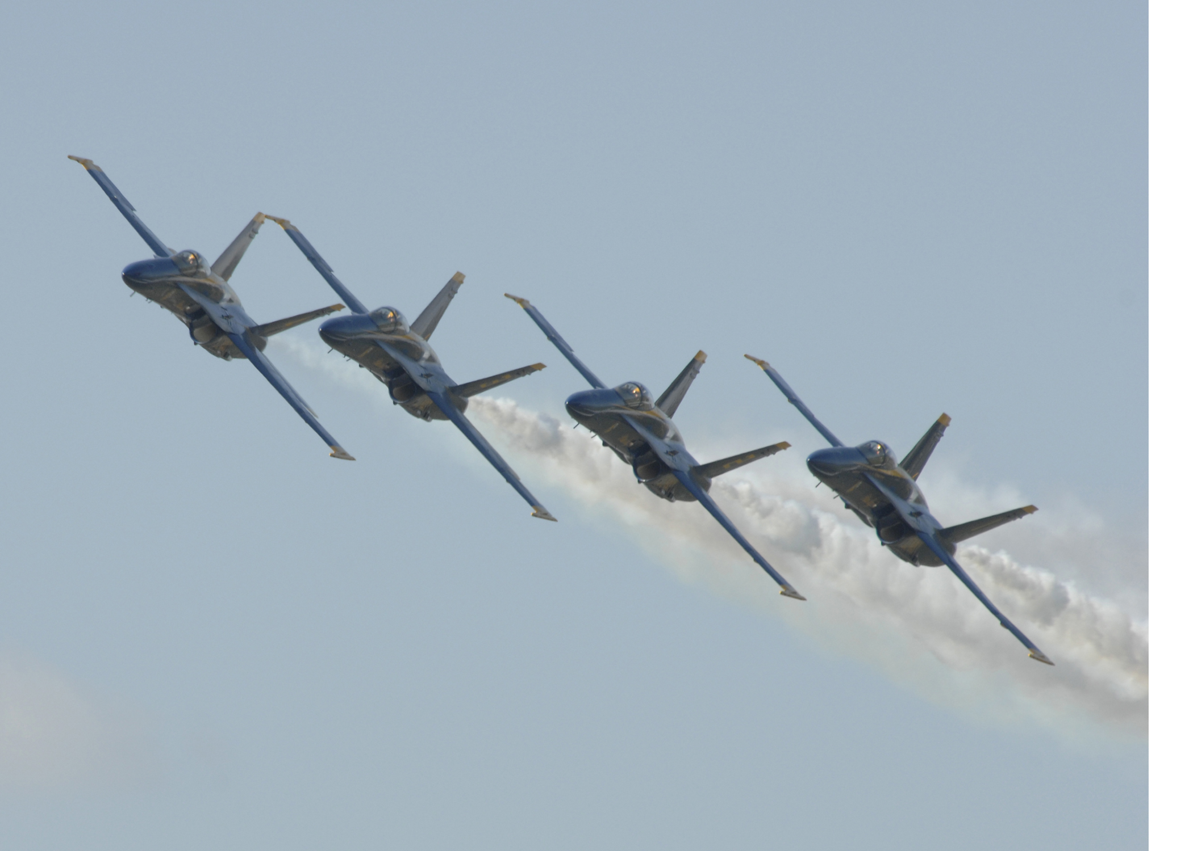
- First Class Professionally Installed Tent
- Mini Chalet includes up to 30 passes per day
- Small Chalet includes up to 60 passes per day
- Regular Chalet includes up to 125 passes per day
- Large Chalet includes up to 250 passes per day
- Super Chalet includes up to 500 passes per day
- Extra passes can be purchased for any chalet, any day for only $50.00 each pass.
- You will also receive 1 VIP On-Site Parking Pass for every 3 admittance passes.
- You can purchase additional VIP On-Site Parking Passes for only $10.00 each pass.
- Private PREMIER VIP Parking right along chalet row - Very limited only $25.00 each pass.
- Private area, fenced in, trash service, restroom service, beverage & ice service, speakers and more
- Professional sign at entrance of chalet
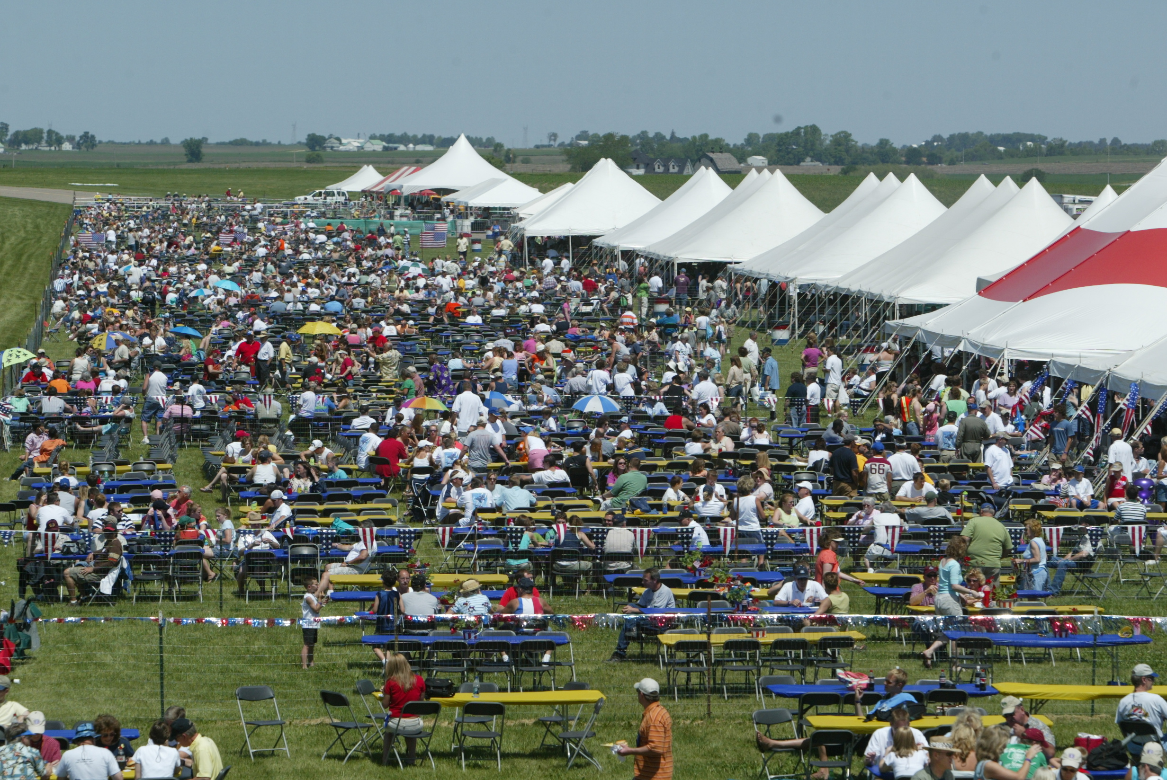
- Promotional announcements through-out the weekend
- Chalet Hostesses to keep area clean & Comfortable
- Professional form fitting Plastic Table Covering at NO CHARGE

ADDITIONAL CHALET ITEMS TO CONSIDER
- Special Plastic Interlocking installed flooring option – call for quote
- Carpet for chalet
- Champaign & glasses and other specialty items
- Flower, Trees, plantings, etc.
- Golf Carts (limited) for ease of getting your important guests around the show grounds
- Please call and we can discuss many more options

* Chalets cannot be sublet without the expressed written permission from the QCAS Chairman or President and then there will be a 50% surcharge for this right. Chalet tickets are good for one day and they are so marked. Once ordered tickets are non-refundable for any reason. If you use a different caterer, they must be pre-approved in writing by the QCAS office and complete a 2019 Official Caterer Request Sheet.

19chaletprices

